**Deliverable 6 Details**

**Project Presentation (10 marks)**

Each group will be given a 15 minute (12 minutes for presentation and 3 minutes for questions/change over) time slot to present their project and demonstrate their system to the class, sponsors and academics in one of the lecture theatres. You must attend the whole session you are assigned to, not just your project presentation. Each team member must participate in the presentation, but not necessarily for the same length of time. The presentation mark will be based on your individual and group mark. Put your name on the bottom of each slide you present.

Your presentation should describe the problem being addressed, what you did to address the problem and how you went about coming up with solutions. Your presentation should include, assessment of (reflection on) the project and software process and future/outstanding work. Demonstrations should contain: Functionality of software, Non-functional qualities of software; examples of how to the system would be used, by whom and for what purpose.

Make sure that your system will run in the lecture room that will be used. Check with the convenor beforehand if in doubt. You may use the internet and computer in the lecture theatre, but if special software is needed you should demonstrate on your own machine.

As shown in the rubric below, a group mark will be given for presentation structure, communication of content and visual aspects of the presentation. An individual mark will be given for speaking/presentation skills. The four measures all overlap somewhat to make a coherent presentation. Presentation structure concerns the sequence in which the content was delivered and the flow of concepts. Communication of content is how is it delivered - via a demo, video, slides, just talking, how well do we understand what the project was about - you might have a nice structure but then it is not well described, the points are not relevant or they contradict. How understandable, logical and informative was the content communicated.

Each item is marked out of 10. The group marks are averaged. The average of the group mark and individual mark will be the mark you receive.

Telling a story

context, problem, approach, value

INTRODUCTION - 1.5 minutes

* Team introduction
  + Noor: Project Manager, Lead Data & Software Engineer
  + Alan: Cloud Solutions Architect & Infrastructure Lead
  + Aasnayem (Adam): Data Engineer & Data Modeller
  + Ninuri: Business Analyst
  + Tash: Business Analyst

Hello everyone, we are Team 14, the EY Data Team, working on a Generative AI solution for NRMA to assist claim agents in detecting fraudulent insurance claims. Today, we’re excited to present our innovative, comprehensive solution alongside Team 13, the AI Team.

To start with a quick team overview: I’m Noorullah Khan, the Project Manager and Lead Data & Software Engineer. Alan is our Cloud Solutions Architect, Adam is the Data Engineer and Modeler, and Ninuri and Tashiya are our Business Analysts.

In terms of workflow, we followed agile methodology, working in two-week sprints with epics to set strategic, long-term goals. For effective project management and planning, we used Atlassian’s Jira tool to track progress and maintain momentum.

Now, moving on to the problem statement, I’ll hand it over to Ninuri.

PROBLEM - 1 minute

* Describe the problem being addressed
* What you did to address the problem

The main problem is that the current fraud detection process at NRMA lacks efficiency and accuracy, resulting in increased operational costs and lengthy processing times thus, needs to be simplified and uplifted through the use of GenAI. Ultimately an end-to-end GenAI solution has to be built that allows the Claims Officer to examine automobile claim reports through a user interface.

2 teams a Data Team and an AI team worked together to develop a solution that can be used to assist claims officers to identify and process fraudulent insurance claims.

EY - split into two team AI and Data to collaborate together and create a model that provide a percentage of how fraudulent a claim in likely to be so the Claims officer can take action.

Data Team Problem

As the data team our main task at hand is to create a high quality dataset of 20,000 rows that will be used by the AI team to train their GenAI model. The main requirements for the dataset is that is should be anonymised with no PII in the dataset as well as include relevant columns for the AI model.

To address the problem we first needed to develop our data requirements. To do this we first started by creating user stories and industry research to help identify the necessary data requirements need to create the dataset. After these requirements were

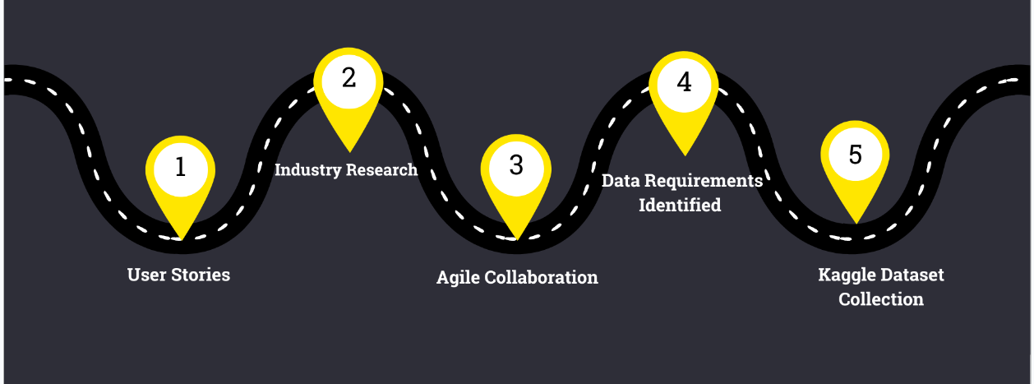

NRMA’s current fraud detection system for automobile claims lacks efficiency and accuracy, resulting in increased operational costs and lengthy processing times. To address this, our team was tasked with creating a high-quality dataset and developing an end-to-end solution, in collaboration with an AI team, that leverages Generative AI to detect fraudulent claims. The project aims to streamline NRMA’s claims processing by enhancing fraud detection capabilities, ultimately reducing costs and improving processing speed through a scalable system deployed on Azure

Today, I will discuss the challenge we tackled as part of our project with NRMA’s claims system. The problem we identified was the inefficiency in detecting fraudulent insurance claims. NRMA’s current system was struggling to accurately detect fraudulent cases, leading to wasted time and higher operational costs. Additionally, without automated solutions, claims officers were burdened with manual reviews, increasing turnaround time.

To address this, our team focused on creating a clean, high-quality dataset that could train an advanced fraud detection AI model. We collaborated closely with the AI team to ensure the data aligned with their model requirements. Along the way, we cleaned, enhanced, and synthesized thousands of data entries to improve accuracy. We also built a web-based interface to help claims officers interact with the AI system in real time, making the detection process faster and more user-friendly.

Through these efforts, we aimed to empower NRMA with a more efficient fraud detection system, reducing review time and operational costs.

SOLUTION - 3 minutes

* How you went about creating the solution
* What is the solution
* Steps in creating the solution

VALUE: 2 minutes

* What is the value of the solution
* How does it bring value to the business/and to the person using it
* Value all around

Currently → [1:20]

**“So, why implement this solution, and what’s its value?”**

When thinking of it in a business perspective Fraudulent claims costs the insurance industry approximately **$2.2 billion every year**. So if NRMA, were to utilise an AI-driven fraud detection model it would be an opportunity to actively combat this issue, reducing financial loss

The model also has significant value for NRMA’s reputation and market standing. By leading the way in AI-based fraud detection, NRMA positions itself as an innovator in the industry.

For NRMA’s claims officers, this model reduces repetitive tasks and provides valuable insights by flagging patterns and anomalies. This enables quicker, more accurate decision-making and allows officers to focus on more complex tasks.

This solution also benefits NRMA’s customers. Faster and fairer claim processing ensures legitimate claims are handled efficiently, making customers feel valued. Satisfied customers lead to increased loyalty and positive word-of-mouth, which enhances NRMA’s market reputation

In summary, this AI solution protects NRMA from fraud, boosts efficiency, and builds stronger customer relationships.

DEMONSTRATION 2 minutes

* Functionality of software
* Non-functional qualities of software
* Examples of how to the system would be used, by whom and for what purpose.

Welcome to the live demo of our Fraud Detection Interface, designed for NRMA claims agents.

### **Key Points to Demonstrate:**

1. **Login & Security**
   * Show the secure login process.
   * Mention: Authorised access only for data protection.
2. **Dashboard Overview**
   * Display the main dashboard.
   * Point out any metrics or overview of pending claims.
3. **Fraud Detection Interface**
   * Select a claim and demonstrate the **Check Fraud** button.
   * Highlight the **Fraud Risk Score** and **Fraud Analysis Summary**.
   * Click **Explain More** for additional AI insights.
4. **Notes & Claim Processing Functionality**
   * Create a live note for a selected claim.
   * Then select a claim outcome and close the case.
5. **Case Retrieval Functionality**
   * Query the case just worked on using case ID.
   * Show aspects like notes, status and fraud risk were recorded and stored.
6. **Non-Functional Qualities**
   * User-Friendly Design: Clean layout for easy navigation.
   * Real-Time Performance: Quick response from the AI for high-volume claim handling.
   * Security & Reliability: Data security through login and stable AI integration.

Overall, this interface boosts efficiency, reduces fraud risk, and helps agents make informed decisions. Thank you for watching!

REFLECTION 1 minutes

* Assessment of the overall project
* future/outstanding work
  + Add visualisation Power BI
  + Integrate with NRMA’a system

Looking back on the project, we are proud of what our team has achieved. We successfully built a high-quality dataset to train NRMA’s fraud detection AI model and developed a working prototype that addresses inefficiencies in claim processing. The collaboration between our data team and the AI team was crucial, and using agile delivery ensured steady progress throughout the sprints. However, every project comes with challenges, and we adapted to evolving requirements to deliver the best results within our scope.

Looking ahead, a few key areas remain for completion. One important next step is to incorporate Power BI for enhanced data visualization, which will provide claims officers with actionable insights. We also need to fully integrate the system with NRMA’s infrastructure to ensure smooth operations. Finally, further development of the front-end design will improve user experience, making the interface more intuitive for claims officers. These future tasks will ensure the solution is robust, scalable, and ready for real-world deployment.